1.

Which of the following sets is well defined?
A.
{Man, Kofi, Red, 14}
B.
{Ink, Mango, Green, Nail}
C.
{Car, Road, Glass, Book}
D.
{Seth, Mary, Jacob, Evelyn}

2.

If set B is a subset of set A, then
A.
sets A and B have the same number of elements.
B.
some members of set B can be found in set A.
C.
no member of set B is in set A.
D.
all the members of set B are in set A.

3.

The least common multiple (L.C.M) of 16, 30 and 36 is
A.
3
B.
6
C.
240
D.
720

4.

The sum of 5 and x divided by 4 is equal to 3.25. Find the value of x.
A.
8
B.
7
C.
2
1
4
D.
-3
4
13

5.

The numbers 32, 33, 34, ..., ..., 42 form a sequence in base 5. Find the missing numbers.
A.
35, 36
B.
30,31
C.
40, 41
D.
31, 41

6.

Write down all the integers in the set A = {-10, -4, 0,
1
4
, 2
1
4
, 45, 100}
A.
{-10, -4, 0, 45, 100}
B.
{-10, -4}
C.
{0, 45, 100}
D.
{
1
4
, 2
1
4
}

7.

Find the total cost of 25 pens and 75 books if each pen costs GH₵ 0.20 and each book costs GH₵ 0.30.
A.
GH₵ 22.50
B.
GH₵ 23.50
C.
GH₵ 27.50
D.
GH₵ 50.00

8.

Simplify: -27 + 18 - (10 - 14) - (-2)
A.
-3
B.
-7
C.
-11
D.
-35

9.

Arrange the following numbers from the lowest to the highest: 0.5, 3, -5, 0.
A.
0, 0.5, -5, 3
B.
0, -5, 0.5, 3
C.
-5, 0, 0.5, 3
D.
-5, 0.5, 0, 3

10.

Find how many pieces of cloth 5
1
2
m long that can be cut from a roll of cloth 121 m long.
A.
665
1
2
B.
115
1
2
C.
66
D.
22

11.

Find the value of 124.3 + 0.275 + 74.06, correcting your answer to one decimal place.
A.
198.6
B.
198.7
C.
892.0
D.
892.4

12.

Esi and Kwasi are 12 and 8 years old respectively. They share 60 mangoes in the ratio of their ages. How many mangoes does Esi get?
A.
42
B.
40
C.
36
D.
18

13.

It takes 6 students 1 hour to sweep their school compound. How long will it take 15 students to sweep the same compound?
A.
24 minutes
B.
12 minutes
C.
3 hours
D.
2 hours

14.

A housing agent makes a commission of GH₵ 103,500 when he sells a house for GH₵ 690,000. Calculate the percentage of his commission.
A.
15.0 %
B.
10.0 %
C.
7.5 %
D.
5.0 %

15.

A simple interest of GH₵ 37,500.00 is earned on an amount of GH₵ 500,000.00 for 3 years. Calculate the percentage rate.
A.
20.0 %
B.
10.0 %
C.
5.0 %
D.
2.5 %

16.

Simplify: (8x²y³)(
3
8
xy⁴)
A.
3x³y⁷
B.
3x²y⁷
C.
3x³y⁴
D.
3xy

17.

The scores of 10 students in an examination are given as follows: 45, 12, 75, 81, 54, 51, 24, 67, 19 and 39. What is the median of the scores?
A.
39
B.
48
C.
51
D.
54

18.

The pie chart is to be drawn from the data in the following table:
Cassava | 20%
Yam | 17%
Plantain | 28%
Maize | 35%
What will be the value of the angle of the sector for maize?
A.
126.0 º
B.
100.8 º
C.
72.0 º
D.
61.2 º

19.

Eighteen cards are numbered from 11 to 29. If one card is chosen at random, what is the probability that it contains the digit 2?
A.
3
9
B.
7
18
C.
5
9
D.
11
19

20.

Find the value of x, if
x
4
+ 1 = 5.
A.
24
B.
20
C.
19
D.
16

21.

Factorize: xy + 5x + 2y + 10.
A.
(x + 5)(2y + 10)
B.
(x + 2)(y + 10)
C.
(x + 5)(y + 2)
D.
(x + 2)(y + 5)

22.

If x ∈ {2, 3, 4, 5}, find the truth set of 2x + 1 < 8
A.
{2, 3, 4}
B.
{2, 3}
C.
{3, 4}
D.
{4, 5}

23.

Solve the inequality: 7x - (10x + 3) ≥ -9
A.
x ≥ 2
B.
x ≤ 4
C.
x ≥ 4
D.
x ≤ 2

24.

Find the rule of the mapping:
1 | 2 | 3 | 4 | 5 | .... | x
↓ | ↓ | ↓ | ↓ | ↓ |  | ↓
7 | 11 | 15 | 19 | 23 | .... | y
A.
x → 4x - 3
B.
x → 3 - 4x
C.
x → 4x + 3
D.
x → 4x + 5

25.

Find the circumference of a circle whose area is equal to 64 π cm².
A.
32 π cm
B.
16 π cm
C.
8 π cm
D.
4 π cm

26.

Which of the following geometric figures is the plane shape of a cube?
A.
Circle
B.
Rectangle
C.
Square
D.
Triangle

27.

How many lines of symmetry has a rectangle?
A.
4
B.
3
C.
2
D.
1

28.

A rectangular box has length 20 cm, width 6 cm and height 4 cm. Find how many cubes of size 2 cm that will fit into the box.
A.
120
B.
60
C.
30
D.
15

29.

The interior angle of a regular polygon is 120º. How many sides has the polygon?
A.
3
B.
4
C.
5
D.
6

30.

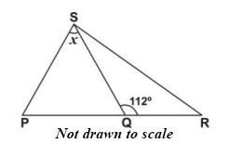
In the diagram above, length of PS = Length of SQ and angle SQR = 112º.
Find the value of x.
A.
68º
B.
56º
C.
46º
D.
44º

31.

XYZ is a right-angled triangle with length of sides as shown.
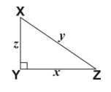
Which of the following equations gives the value of z²?
A.
z² = (x² + y²)
B.
z² = (x - y)
C.
z² = (y² - y²)
D.
z² = (x² - y²)

32.

Express 7 min. 30 sec. as a percentage of 1 hour.
A.
2.5%
B.
7.5%
C.
11.7%
D.
12.5%

33.

The point (4, 5) is translated to the point (3, 1). What is the translation vector?
A.
(
-1
4
)
B.
(
1
4
)
C.
(
1
-4
)
D.
(
-1
-4
)

34.

In the diagram below, triangle QRT is the enlargement of QST.
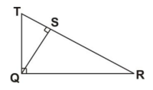
Which side of triangle QRT corresponds to side QT of triangle QST?
A.
TS
B.
TR
C.
QR
D.
SR

35.

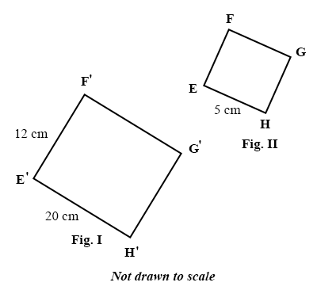
In the diagrams above Fig. I is an enlargement of Fig. II. Find the side EF of Fig. II.
A.
20 cm
B.
5 cm
C.
4 cm
D.
3 cm

36.

Express 4037 in standard form.
A.
4.037 x 10⁻⁴
B.
4.037 x 10⁻³
C.
4.037 x 10³
D.
4.037 x 10⁴

37.

Which of the following angles can be constructed by using the arcs at point C in the diagram below?
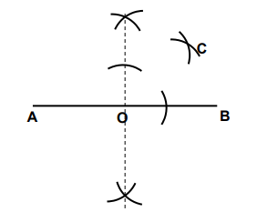
A.
30º
B.
45º
C.
60º
D.
75º

38.

Given that vector a =
(
-5
12
)
and b =
(
10x
12
)
Find the value of x if a = b.
A.
-2
B.
-
1
2
C.
1
2
D.
2

39.

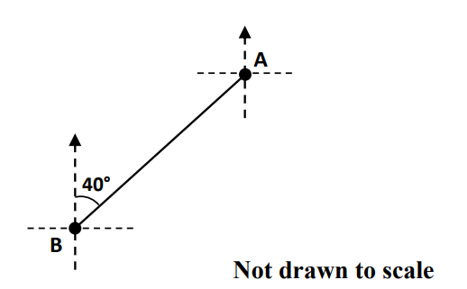
In the diagram above, the bearing of point B from A is
A.
340º
B.
220º
C.
140º
D.
50º

40.

Ama is 9 years older than Kwame. If Kwame is 18 years old, find the ratio of the age of Kwame to that of Ama.
A.
3 : 2
B.
1 : 3
C.
2 : 3
D.
2 : 1

